The Illinois State Budget Impasse: Impact on
Low-Income Seniors

February, 2017

Table of Contents
Acknowledgments 2

Key Findings 3

Introduction 4

Background 5

The Timeline 12

The Impasse 13

The Impact

Service Providers 16

Seniors 20

The Community 25

The Future 27
Conclusion 31

Citations 32

Acknowledgments
We want to thank everyone who graciously lent us their time and energy to make this report possible. Listed below, in no particular order, are organizations and individuals who shared their expertise, stories, and connections with us; without them, this report would not have been made possible. Thank you.

Brice McKeever, PhD, Research Fellow I, Urban Institute Center on Nonprofits and Philanthropy
Paula Wills, Executive Director, HealthVisions of East St. Louis
Clifford Broaden, senior client, HealthVisions of East St. Louis
Garland Miller, senior client, HealthVisions of East St. Louis
Pat Riegel, Volunteer Driver, HealthVisions of East St. Louis
Shirley Hicks, senior client, HealthVisions of East St. Louis
Jonathan Becker, Executive Director, Senior Services Plus
Theresa Collins, Associate Executive Director, Senior Services Plus
Jerome Tucker, Driver, Senior Services Plus
Cindy Cunningham, President, Illinois Adult Day Services Association
Kathy Gardner, Senior Vice President, Community Investment Division, United Way of Great St. Louis
Samantha Sherrod, Funding Manager, Community Investment Division, United Way of Greater St. Louis
Joy Paeth, CEO, AgeSmart Community Resources
Jon Lavin, CEO, AgeOptions
Judith Gethner, Executive Director, Illinois Partners for Human Services
Nancy Berry, Executive Director, St. John's Community Care
Shari Armstead, Director, Continuum of Life Care Center

Key Findings
The Daughters of Charity Foundation of St. Louis sought to learn more about how the Illinois budget impasse is affecting low-income older adults, their families, and service providers. The Foundation tasked four Coro Fellows, Sarah Cornett, Evan Glantz, Kevin Hutchins, and Livi Logan-Wood, with conducting research and creating this report to tell a compelling story. The Fellows spent four weeks gathering information through online research, data analysis, interviews with key stakeholders, visiting communities, and speaking with low-income seniors.

The objective of this report is to communicate the experiences of low-income seniors and service providers in eight counties in southwest Illinois: Jersey, Macoupin, Madison, St. Clair, Bond, Monroe, Calhoun, and Clinton. The key findings from this research include:

- The budget impasse has disproportionately affected low-income populations. Seniors have been impacted most due to cuts in home delivered meals, transportation, adult day services, and home care.

- The human service sector had not experienced reimbursement rate increases for several years prior to the budget impasse.

- Nonprofits in Illinois have historically relied heavily on government funding.

- The absence of a budget has made long-term planning difficult for nonprofits.

- Service providers have been forced to come up with alternate ways to fund their organizations due to delayed payments from the state.

- The human services sector is declining as the need for services is steadily growing.

Introduction
The state of Illinois has been without a budget since July 1, 2015. This is a result of disagreements between GOP Governor Bruce Rauner and a Democratic General Assembly, and has had a significant impact on state funding for human services. Without a budget, the state has struggled to plan for the future, make consistent payments to contracted organizations, and keep up with consent decrees and court ordered payments. A stopgap budget passed for the final six months of 2016 expired on December 31, 2016, leaving service providers in a state of uncertainty for the future.

Service providers, researchers, and government officials are struggling to fully understand and predict the ramifications of this budget impasse. Across Illinois, organizations have had to stop providing services and completely shut down -- yet no one is quite sure what the effect has been on individuals, or how many places have closed. There is a sense that people are simply trying to hold out until another budget is passed. However, given the recent disagreements in the General Assembly over new budget proposals, it does not seem as though a compromise between Republicans and Democrats will be reached in the near future.

Throughout the past four weeks speaking with those affected by the situation, it became clear that there is a sense of urgency among providers to find solutions to the current circumstances. Despite substantial dependence on the state, several organizations have focused on diversifying their funding streams and have been able to continue serving their clients without cutting back significantly.

The senior voice in this report is captured through interaction with clients of two organizations and is mixed with concern and gratitude. While the seniors were thankful for the assistance they receive, such as transportation and home delivered meals, many of them indicated feeling stressed over the idea of losing certain services. Others described their lack of faith in the government.

This report is meant to combine data with narrative stories to depict the situation many people face in Illinois as accurately as possible. The main thing that has been extrapolated from these findings is that the current practices regarding senior services among the state and their contracted providers are not sustainable for much longer. It is unknown what would happen if the budget impasse extended for several months, however speaking with service providers, it is clear that they do not feel confident it will be possible to keep their doors open, leaving seniors vulnerable and underserved.

Background
Human Services

Before the budget impasse began in Illinois during the summer of 2015, funding for human services in the state was failing to keep up with increasing cost of living. In order to provide direct services, the state contracts with community organizations and provides funding intended to cover related costs. An analysis conducted by Illinois Partners for Human Services examined reimbursement rates, compared them to the Consumer Price Index and expanded on challenges resulting from stagnant funding. Their research reported that service providers are not only struggling to keep up with the actual costs of delivering adequate services, they are also dealing with high staff turnover rates of staff, unmet needs of clients, and limited recruitment due to low wages.

This analysis included a focus on seven human services fields: Substance Abuse Treatment, Senior Services, Child Care, Early Intervention, Residential Child Welfare, Developmental Disabilities Services, and Community Mental Health Services. Although several of these fields have not seen reimbursement changes in over 10 years, Senior Services in particular has experienced the longest time without an increase. For example, Care Coordination Services have not been adjusted since 2000, meaning that in order to account for cost of living, the state of Illinois would have to increase the reimbursement rate by 38 percent to bring it to today’s value. Furthermore, the Community Care Program, which includes Adult Day Service, In-Home Care, and Transportation, would need to increase by at least 9 percent to align with cost of living changes.

Nonprofit Data

The impact of the budget impasse can be seen across all sectors, from nonprofit to government to the private sector. In order to compare and contrast the southwest Illinois landscape before and after the budget impasse started, data was pulled and analyzed from the Urban Institute’s National Center on Charitable Statistics (NCCS). Taking into consideration the condition of Human Services in Illinois before the budget impasse took place, it is also important to examine the status of service providers as well.

Looking at the National Center on Charitable Statistics data on the public charities that file 990 tax forms to the IRS is one way to grasp an organizational landscape. NCCS derives its data files primarily from information that tax-exempt organizations file with the Internal Revenue Service. The IRS provides this data to NCCS, which then cleans and prepares the data for analysis. Two primary NCCS databases were used in this analysis: the IRS Business Master Files (BMF), and the Core Fiscal Year Trend File (Core Trend). Both files include information derived from the aforementioned tax forms: total revenue, total expenses, assets, etc.. For the purpose of this report, the number of organizations and their total revenues will be used as the key indicators for growth in the sector.

The chart below displays the change in the total number of nonprofit organizations in southwest Illinois, compared with senior service organizations. This data comes from the Core Fiscal Year Trend Data ranging from 1989-2013. This data set contains the information for all public charities active within a given fiscal year, including all organizations filing a Form 990 or 990-EZ in the given fiscal year.

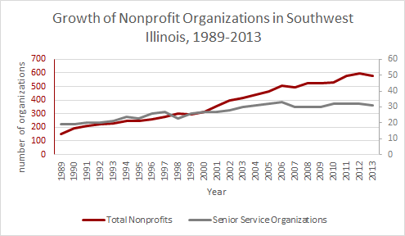
Source: The Urban Institute, NCCS Core Public Charities Fiscal Year Trend Data (Public Charities, 1989-2013)

Looking solely at the trend lines, it would appear in southwest Illinois that all nonprofits were growing at similar rates with senior service nonprofit organizations. However, paying acute attention to the scales for each grouping shows that for senior service nonprofits, growth occurring from 1989 to 2003 was an increase from 19 to 30 organizations, an increase of 57.9 percent. Over the same time period, all nonprofits filing 990s increased from 152 to 415 organizations, which equates to a 173 percent increase. From 2003 onwards, senior service nonprofits that filed grew to a high of 32 organizations total, an increase of 7 percent. Meanwhile, all nonprofits continued to increase to a high of 594 organizations in 2012, a much larger 43 percent increase.

The National Center for Charitable Statistics Core Fiscal Year Trend Data for the eight counties indicates trends regarding revenue. Of the 32 total organizations that filed 990s consecutively leading into 2013, 17 senior service organizations saw positive trends in total revenue, 10 had no clear pattern, and 5 had negative trends. Accompanying changes in expenses saw 17 out of 32 organizations running a budget deficit in 2013, up from 16 in 2012 and 13 in 2011.

Looking at the National Center for Charitable Statistics’ IRS Business Master Files, senior service organizations in southwest Illinois saw various changes in total revenue over the past few fiscal years beyond what the Core Data shows. These master files are more closely tied to the particular IRS filing period and the relevant information for that particular time. They have not been merged into the Core Data, and as a result need to be compared from year to year.

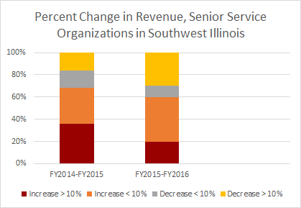
Source: The Urban Institute, NCCS Core Public Charities Fiscal Year Trend Data (Public Charities, 1989-2013)

The chart above depicts the revenue changes experienced by 32 senior service organizations in southwest Illinois. The number of organizations that saw a 10 percent increase in revenue decreased from 2014-2015 to 2015-2016, and the number of organizations that experienced decreases greater than 10 percent also increased in the same period. Overall, revenue for all senior service organizations in southwest Illinois changed from an average of an 11 percent increase to a 3 percent increase.

Population

Estimates of population in 2015 from samples conducted after the 2010 Census indicate that overall population is decreasing in Bond, Calhoun, Jersey, Macoupin, Madison, and St. Clair Counties (Clinton and Monroe saw slight increases). Based on these estimates, the average change for all eight counties is an approximate decrease of 2 percent.

Meanwhile, estimates of persons age 65 years and over made in 2015 indicate an increase across the board. On average, the percentage of the population age 65 and over in southwest Illinois is estimated to have increased by more than 2 percent. The percentage of the population age 65 and over is also higher in these counties than Illinois as a state.

Persons 65 years and over, percent | Bond | Calhoun | Clinton | Jersey | Macoupin | Madison | Monroe | St. Clair
July 1, 2015, estimates (V2015) | 17.0 | 23.2 | 16.3 | 18.0 | 19.3 | 15.9 | 16.4 | 14.3
Census Data April 1, 2010 | 15 | 20.1 | 14.5 | 15.7 | 17.1 | 14.3 | 14.1 | 12.5
Source: United States Census Bureau, QuickFacts Data http://www.census.gov/quickfacts/table/PST120215/17119,17117,17083,17027,17013,17005 and http://www.census.gov/quickfacts/table/PST045216/17,17163,17133,00

These shifts in population (an overall decrease in total numbers occurring simultaneously with an increase in the percentage of the senior population), poses a difficult situation. As the working-age population decreases, either from moving away or reaching retirement, the local tax base decreases. This creates potential strain on local governments’ budgets, which becomes even more serious as the state continues to lack a budget.

Geographically, the population per square mile in these counties as recorded in the 2010 Census ranged from as low as 20 and 46.7 people per square mile in Calhoun and Bond County, respectively, to 376.3 and 410.6 people per square mile in Madison and St. Clair County. Across all eight counties, the average was roughly 142 people per square mile. For reference, the whole state of Illinois had 231.1 people per square mile overall. This means that the people of southwest Illinois are more geographically spread, living in rural areas.

There are a few arguments to consider as possible consequences. People in southwest Illinois are living in further isolation from each other. This is more relevant to older adults more likely to be homebound, as their potential sources of support may be coming from further afield. These sources of support include home care and meal delivery, which contribute to transportation costs, further adding strain to budgets.
The Administration for Community Living breaks down the 2010 Census data further into separate five-year age brackets.

County | Total Population  (number) | Age 65 and Older  (%) | Age 60-64 (%) | Age 65 - 69 (%) | Age 70 - 74 (%) | Age 75 - 79 (%) | Age 80 - 84 (%)
Bond | 17,768 | 15.00 | 5.80 | 4.10 | 3.50 | 2.80 | 2.30
Calhoun | 5,089 | 20.10 | 6.80 | 6.00 | 5.00 | 3.80 | 2.70
Clinton | 37,762 | 14.50 | 5.10 | 4.00 | 3.20 | 2.90 | 2.30
Jersey | 22,985 | 15.70 | 5.80 | 4.60 | 3.80 | 2.90 | 2.30
Macoupin | 47,765 | 17.10 | 6.20 | 4.80 | 3.70 | 3.30 | 2.60
Madison | 269,282 | 14.30 | 5.50 | 4.20 | 3.20 | 2.70 | 2.20
Monroe | 32,957 | 14.10 | 5.20 | 3.90 | 3.20 | 2.70 | 2.30
St. Clair | 270,056 | 12.50 | 5.00 | 3.60 | 2.80 | 2.40 | 2.00
Source: Administration for Community Living, agid.acl.gov. Data Source: Decennial Census 2010 Summary File 1 (SF1) Data, accessed January 31st, 2017

Given that it has been seven years since these figures were calculated in 2010, members of each bracket have aged into the next bracket, or two depending on starting age. This indicates an increase in the number of seniors across the board, most notably for older adults aging from ages 60-64 into ages 65-69, when most seniors begin to qualify for Medicare and Social Security. For the whole state of Illinois, the percentage of total seniors 65 and over is 12.5 percent, well below the figure for seven of eight counties.

The next table with data from the Census Bureau’s American Community Survey highlights estimates of the population of seniors in southwest Illinois who are also living in poverty.

Percentage of families and people age 65 and older with income below the poverty level
County | Bond | Calhoun | Clinton | Jersey | Macoupin | Madison | Monroe | St. Clair
2010 | 9.1 | 13.2 | 5.7 | 7.1 | 5.5 | 6.6 | 2.4 | 9.7
2015 | 7.8 | 6.6 | 7.8 | 5.6 | 6.4 | 6.8 | 5.6 | 8.7
change | -1.3 | -6.6 | 2.1 | -1.5 | 1.1 | 0.2 | 3.2 | -1.0
Source: United States Census Bureau, American Community Survey 5-Year Estimates

Changes in this population varied from county to county, with increases in four of the eight counties, and decreases in the other half. Overall, as most recently estimated in 2015, the percentage of the population age 65 and older living below the poverty level in southwest Illinois is 6.91 percent. While this is not greater than the figure for the whole state, 8.6 percent, it is worth considering in connection with the number of service providers in the area.

What the Data Tells Us

There are several limitations in using data to describe what is going on in a landscape as variable as older adults in southwest Illinois. First, data is only as applicable as when it was most recently collected, which for some economic and population data is years old. The reality of today’s situation can only be extrapolated from what has occurred in the past, and the data may not properly project onto the current situation. Additionally, using numbers and percentages to describe an entire region of people and organizations is not effective in communicating the impact of this situation on quality of life. It is necessary to supplement the above with a direct look into what is going on for people on the ground in southwest Illinois.

The fact that the senior population is increasing across the board while organizations serving them has remained static indicates a strong possibility that new seniors may not have access to organizations with the bandwidth to serve them. This could be linked to the state’s static funding of reimbursement rates related to Senior Services, which has limited that capability for service providers to expand their resources. Additionally, another point to consider is that as older adults are living longer, it will require more resources to serve them.

Another supporting argument is seen in the overall trends in revenue of these organizations. As these organizations have diminishing revenue, they have fewer funds with which to provide programs and services to older adults. Given that half of the senior service organizations in southwest Illinois were already operating in budget deficits in 2013, there is evidence of strained efforts to keep afloat. Decreases in revenue and current levels of senior services available paired with an increase in demand from a growing elderly population make for a desperate situation. Some of the most vulnerable go without support.

The data describing the population for people over the age of 65 living in poverty pulled from the American Community Survey shows both positive and negative trends. Half of the counties in southwest Illinois have decreased the percentage of seniors living in poverty, while the other four have experienced a slight growth in the senior population in poverty. This is significant because it mirrors findings that the growth of senior services and impact that they have on communities has been somewhat stagnant. Calhoun County is the only area that refutes this trend with a decrease of 6.6 percent of seniors living below the poverty level between 2010 and 2015. Taking that into consideration, the percentage change across the rest of the seven counties is a 1.5 percent increase in the number of people over the age of 65 living below the poverty level.

There are criticisms that the official poverty level does not fully capture the population of people experiencing poverty. Some include:

- The official poverty measure indicates the number of people living below the poverty threshold but does not measure the extent of economic need.
- The measure does not adjust for geographic cost of living across the United States.
- It is not adjusted for the changes in standard of living over time.

Despite all this, the fact remains that a population of seniors in southwest Illinois will continue to require services in the future. The state has not equipped itself with the resources and funding to properly support the growing population.

The Timeline

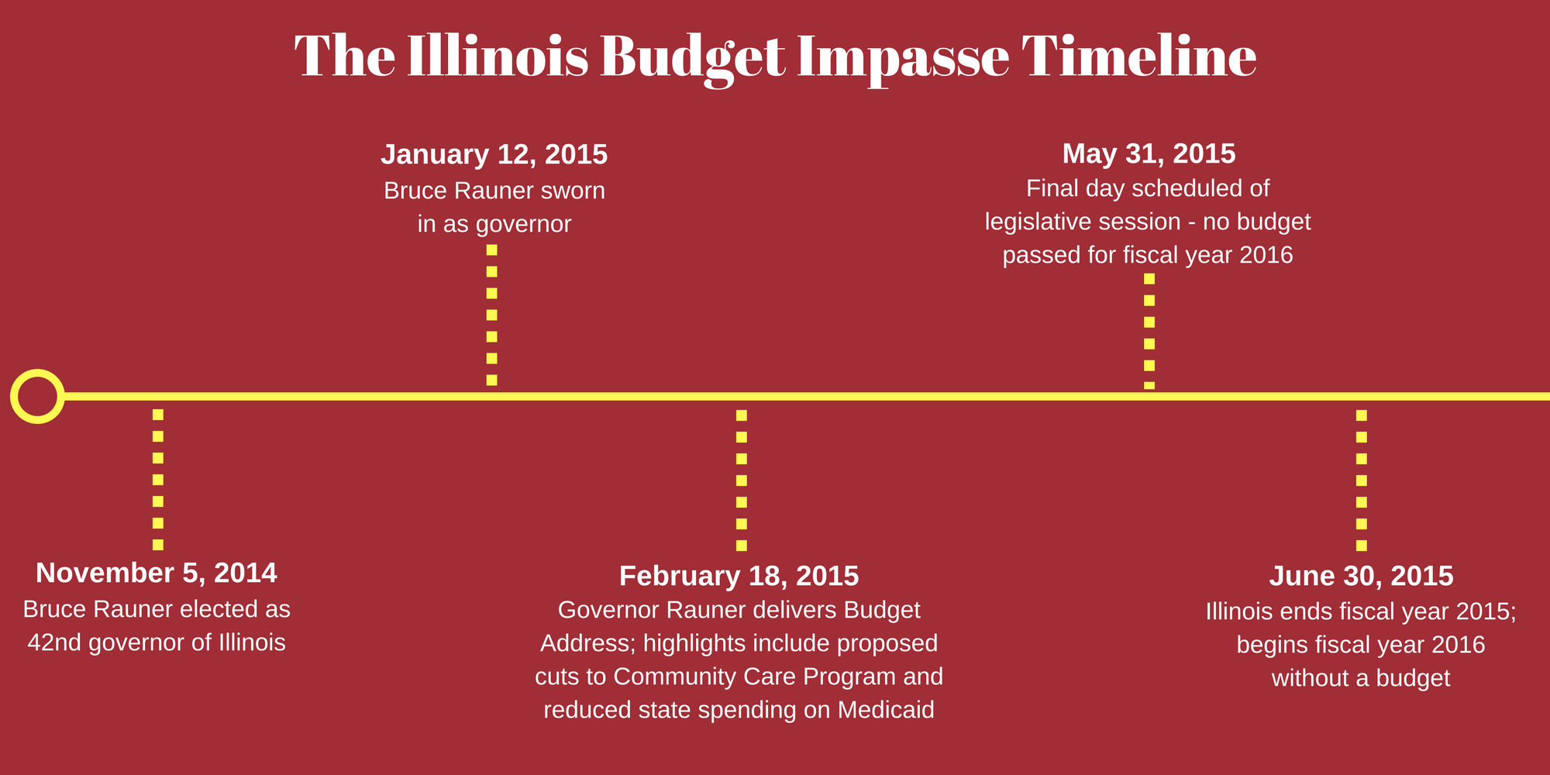

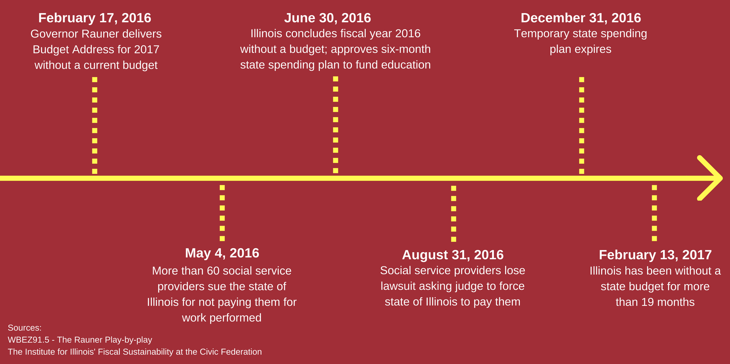

The Impasse
Political Strife

On January 1, 2015 a temporary Illinois income tax expired, lowering the tax rate for residents from 5 percent to 3.75 percent. The expiration also affected the corporate income tax rate, reducing it from 7 percent to 5.25 percent.

With Illinois already facing a budget deficit of $2 billion, Democrats, who control the Illinois Legislature, wanted Governor Bruce Rauner to reinstate the tax, which served as a revenue generator for the state. Governor Rauner said he would consider it, with the condition that the Legislature would approve his pro-business proposals, which would result in weakening union influence in Illinois. His proposals included loosening existing worker compensation protections, allowing local governments to opt out of the collective bargaining process with their employees, reducing the cost to businesses of workers’ compensation, and more.

Democrats, led by House Speaker Michael Madigan, opposed these measures, arguing that they were not related to the budget. In addition, they believe Governor Rauner’s proposed changes would hurt middle class families and unions, among others.

With neither side willing to compromise, Illinois began the 2016 fiscal year without an approved budget. The standoff has continued into 2017, and July 1 will mark two years without a budget for the state.

Consent Decrees

In the time between July 1, 2015 when the budget impasse began and now, the state of Illinois has stopped payment in some areas of the budget, and has also been forced to continue payments in other areas. Consent decrees and court ordered payments are both methods by which service providers are continuing to be reimbursed for their work.

Consent decrees are, by definition, agreements that the state makes in order to settle lawsuits. They are filed on the basis that the state is not adhering to federal guidelines on a specific issue. The most common recent examples have dealt with the Department of Justice, however consent decrees have existed for decades in the state of Illinois, most of them dealing with human services and health care.

Today, the state of Illinois is implicated in 80 consent decrees. Some examples of consent decrees that have been enacted include ones addressing problems in the state’s Department of Children and Family Services and enforcing the rights of people with developmental and physical disabilities.

When Governor Bruce Rauner was sworn into office in January 2015, he stated that a goal of his administration was to get out of the state’s consent decrees. When the budget impasse began later the same year, the American Civil Liberties Union of Illinois released a statement outlining their intent to defend consent decrees and ensure that the payments would continue to come through. Throughout the past 19 months, Governor Rauner has continued to express his criticisms of consent decrees, and they have continued to be paid without a budget, contributing to the mounting debt the state faces.

Court Ordered Payments

Court ordered payments have continued to fund certain services since the budget impasse. Within the first month of the impasse, state courts began ordering that programs, such as foster care, Medicaid, and assistance for adults with developmental disabilities, continue to receive payments based on the most recent budget from 2014. Both the Legislature and the governor agreed that the previous year’s budget was not satisfactory, and there was hope that a budget would be passed before the end of 2015. Given that this is not the case, court ordered payments to keep the state functioning have persisted and many service providers receiving these payments are operating on an outdated, three year old budget.

Debt

Despite having no budget and annual spending plan in place, the majority of Illinois’ state spending - as much as 90 percent - is paid through consent decrees and court ordered payments. The remaining bills that have not been paid through those methods have resulted in a backlog totaling $11 billion.

Illinois state law says that unpaid bills begin to earn interest at a rate of 1 percent per month if they are not paid within 90 days. The law also says that bills from health care providers earn interest at a rate of 9 percent per year after 30 days. As a result, it is estimated the state owes $370 million in interest alone for state employee health care during the impasse.

In total, Illinois owes more than $11 billion in backlogged bills, a state record that continues to grow daily. At this current rate without action, Illinois is expected to have a $13 billion deficit by July, which would mark two years since the start of the budget impasse. According to the St. Louis Post Dispatch (2/16/17) the state pension programs are $130 billion short of what they need to pay promised benefits to retired and current employees.

In addition to the mounting debt, the impasse has negatively affected the Illinois economy in other ways as well. The state cannot maximize investment opportunities, and is missing out on some altogether. It has also seen its credit rating drop to BBB in the Standard & Poor’s rating system, which means the quality of the bonds they issue is lower medium grade.

The gap between spending and revenue for the state preceded the impasse, and in part caused it. The budget impasse, however, has magnified and widened the very gap that Governor Rauner and the state Legislature are trying to close.

Impact on Service Providers
General Challenges

The partisan stalemate occurring in the state government has disproportionately affected vulnerable, low-income, and disadvantaged populations. This has placed an enormous strain on the nonprofit infrastructure across the state of Illinois to continue providing services without adequate funding. Specifically, the inability of the state to honor its contracted payments to community organizations has forced many providers to cut back on clients served, programs and assistance, and even close their doors indefinitely. Our field interviews with service providers resurfaced the same narrative time and time again: the state’s lack of a budget has inflicted high levels of stress, turnover rates, disappointment, and distrust of the state government among staff.

The unintended consequences of the budget impasse related to unemployment, income inequality, and preventative care have many service providers and community members fearing that this situation will leave the state worse off than many realized. A specific concern relates to the possibility that the state will accept decreased funding for human services as a “new normal” and not adjust reimbursement levels to fit today’s cost of living. Given that reimbursement rates for most human service programs in Illinois were already insufficient when compared to the Consumer Price Index, this concern has strong possibility of becoming reality.

Human Service Programs

Since the budget impasse began in July, 2015, nonprofits providing programs mandated by the state constitution were paid, although these payments are frequently late. Furthermore, organizations providing non-mandated services may have not received payments, but were still required to provide services outlined in their contract with the state. This occurrence was referenced throughout our field interviews and seemed to indirectly create a situation where services have been spread so thin that quality of care is at stake.

Focusing on the nonprofits providing seniors services, nonprofits in this field have experienced losses in program payments from the Illinois Department on Aging (IDOA) totaling nearly $200 million. The majority. or 67 percent of the late payments, are under the Home Delivered Meals program.

Records show that the budget for human services was decreased by $383 million between 2015 and 2016. This is a substantial amount of money -- about 31 percent of the Department of Human Services funding and 30 percent of the Department on Aging’s total funding. This directly impacts a population that needs these services the most, and imposes unprecedented stress and secondary trauma on the service providers themselves. In interviews, staff recounted stories in which they had to turn away longtime clients, knowing that those clients had nowhere else to call for transportation or care, and others spoke about times in which they had found clients who had fallen and had not been checked on for days. Speaking with service providers, their concern and the gravity of the situation could be detected in their voices. Many of the providers doubted that they could stay operating for much longer if the circumstances did not change.

Mission-Centered Approach

There was one commonality found that was shared among all of the service providers spoken to for this report: they would do whatever it took to keep their doors open. Many community organizations have been forced to deplete cash reserves, open and exhaust credit lines, and apply for more grants. Some organizations, such as HealthVisions of East St. Louis, have accepted clients that were formerly served by organizations that closed due to delayed payments from the state. Others have continued to operate without being able to pay their staff. Additionally, several agencies have made their presence known in Springfield, advocating for their clients and pushing legislators to create solutions to the crises that state faces.

The senior service providers in southwest Illinois seem to be working in tandem with one another to stretch services as far as possible. Key stakeholders we spoke to for this report knew one another well and there are monthly conference calls that service providers participate in in order to discuss state and federal issues. In this research, it appears as though the network of service providers is strong and collaborative.

Service Provider Narratives

Continuum of Life Care Center

At its peak, the Services for Older Adults - Homemaker Services, a program of the Lessie Bates Davis Neighborhood House, had 290 seniors relying on their services, provided by a staff of 117 homecare workers. Then on April 30, 2016, the organization cut the program, leaving clients without coverage, and employees without the work about which they were so passionate.

In the months leading up to its closing, the Services for Older Adults program had been operating at a deficit of more than $220,000 of its $2 million annual budget. Staff had been laid off and services had been cut back, and still the program could not sustain its efforts. The situation deteriorated to the point that the Continuum of Life Care Center could not even afford to purchase ink pens.

Despite the hardships and loss of resources, many former homecare workers continued to check in on the seniors they worked with, and made personal home visits to deliver meals. No financial support was given to the homecare workers.

The program laid dormant for a couple of months. In late July, Lessie Bates finally received payments from the state of Illinois and also secured new grant funding. Due to the program’s long and successful history, a proposal was put together to reopen the Services for Older Adults. On August 1, 2016, the Center reopened, albeit with no staff and no clients.

Since then, their growth has been methodical. They are not allowed to contact former clients directly, although they can reach out to former homecare workers. Though some had found work at other centers, many were eager to rejoin the Lessie Bates family. As of January 2017, the Services for Older Adults has 60 clients supported by 23 homecare workers, which represents about 25% of their original client base.

The struggles are far from over so long as the Illinois budget impasse persists. However, there appears to be a renewed sense of optimism. Seniors are transported to and from the Center every day, and the home delivery meal program is back in operation. Mondays and Wednesdays, seniors are delivered one hot meal and one frozen meal, and they are delivered another hot meal on Fridays. At the Continuum of Life Care Center, clients take part in a variety of activities such as bingo, dancing classes, exercise classes, and more.

For more than 106 years, the Lessie Bates Davis Neighborhood House served countless metro east residents of all ages. That passion for service has been instrumental in the reestablishment of the Services for Older Adults and development of congregate meals at the agency’s Continuum of Life Care Center.

Theresa Collins, Associate Executive Director, Senior Services Plus

Theresa Collins, the Associate Executive Director of Senior Services Plus in Alton, Illinois, says the agency’s scaleback of its Meals on Wheels program is just one part of cutbacks due to the impasse. The organization has laid off staff and borrowed money to try to make up the difference from what they had been receiving from the State of Illinois in Department of Aging funding and federal grant matching.

“We’re talking about hundreds of thousands of dollars we’ve lost,” she said, speaking about the almost two-year period since the impasse began. “It puts a lot of pressure on you, to try to figure out creative ways to manage providing those necessary services.”

Expanding the agency’s food and catering service has helped to make up some of the gap in state funds. Still, the agency is borrowing more money that it ever has, accruing debt and interest in urgent effort to continue to support the seniors it serves.

SSP has laid off 15 of its staff members due to the impasse, a decision Collins makes clear was extremely difficult. When they left, they took years of expertise and investment in the community. This poses significant challenges for a town already struggling with population loss like Alton.

“Rebuilding the infrastructure we’ve lost in the past two years will take 20 years,” she said.

But some of the impasse’s most pressing consequences, Collins says, are emotional. While sitting in SSP’s cafeteria, filled with seniors coming from the Wellness Center, she fields warm wishes and hellos. It’s clear from observing the room that SSP is a major part of these seniors’ lives.

After being offered lunch by an older gentleman in workout gear, Collins turned back to the impasse. She described the shock the cutbacks have reverberated throughout the SSP community.

“It’s caused a huge scare with staff and seniors. They worry what will happen to them if SSP doesn’t exist.”

SSP employs 400 people and, in Collins’ words, “touches over 35,000 seniors each year.” If the agency were to shut its doors due to funding losses, she said, the costs to the community would be irreparable.

“If we close and lay off 400 people, think of the expense to both the community and the state.” she said.

Many of those seniors would lose interaction and health services essential to their well-being and could risk going into institutional care when all they may need is a daily check-in and meal.

Like other agencies facing similar problems in Illinois, SSP has borrowed and sought more in foundation grants and individual donations. Still, she says that those funding sources have gotten more competitive.

“As a nonprofit, we’re already at a thin margin,” she says. “Now more organizations are competing for the same dollars.”

Impact on Seniors
Isolation and Depression

Older adults experience higher levels of depression and isolation than adults under 65. Studies have shown that a decline in social interaction and adverse physical health effects that can unfortunately accompany aging contribute to these differences. Seniors also experience higher levels of loss than those under 65. The death of a friend, spouse, siblings, or other family members who are seniors can also contribute to higher rates of depression.

According to a 2010 National Institute of Health study, isolation and depression, in addition to genetics, heighten the risk of dementia in seniors. The correlation can go both ways. Seniors suffering from dementia and Alzheimer's also had higher rates of depression.

The same study showed that living situation can significantly impact mental health. Researchers found that seniors who live in long-term care facilities are between 14 percent and 42 percent more likely to experience depression than those who live at home.

The Value of Interaction

Research shows that social connections play a key role in the health of seniors. Regular conversation and interaction are health protective, according to reports from the National Institute on Aging. A 2014 study authored by an epidemiologist at Drexel University found that seniors living in areas with high social “capital,” with high availability and frequency of conversation, had higher rates of mobility than seniors who did not. Seniors in high social capital neighborhoods were additionally 20 percent more likely to have regular health check-ups.

Regular social interaction has been proven to promote mental health as well. A 2013 study conducted by the Rush Alzheimer’s Disease Center in Chicago found that rates of cognitive decline were 70 percent lower in seniors who had higher rates of social interaction. The study ultimately found that seniors with low social activity were 57 percent more likely to have higher rates of disability than those who lived in high social capital environments.

Aging in Place

Many seniors value being able to stay in their home and communities as long as possible. If isolated, however, seniors can risk adverse health effects. Home and community-based care, which includes many of the home visit services offered by agencies that serve seniors, enables seniors to “Age in Place” in a way that supports a desire to remain in their homes while promoting healthy interaction.

Community-based care also lowers the potential of premature institutional care. A 2014 Illinois Partners report cites home and community-based care as significantly decreasing the risk of seniors entering a nursing home before it’s essential. For a senior on Medicaid, the cost of institutional care can be upwards of $4,000 a month. Compare that to the $4.50 daily cost of a hot meal delivered to a senior, which includes a daily check-in that promotes the kind of interaction we know to be essential for homebound seniors’ mental health.

If a senior requires more intensive care than a daily check-in and meal, home health aides have been proven to be a more cost-effective measure that support “Aging in Place.” A 2008 study on institutional care for seniors found that a home-health aide costs public insurance 50 percent less than hospitalization. These studies show that preventative home and community based services both positively support mental health and wellness for seniors, and offer far more cost-effective treatment than institutional care. If the State of Illinois is considering root causes and interested in saving costs to Medicaid, robust support of home and community-based services is a solution that works according to these studies.

Senior Narratives

Interviews and conversations with seniors reveal the personal costs of the impasse. Below are the stories of Jerome Tucker and four seniors from HealthVisions of East St. Louis, Garland Miller, Clifford Broaden, Shirley Hicks, and a volunteer driver Pat Riegel.

Jerome Tucker, SSP Meals on Wheels Driver

On a cold January day in Alton, Illinois, Jerome Tucker is doing what he does each morning-- counting pieces of bread, cartons of milk, and placing bags of frozen meals into coolers.

“When it’s warm, we have to make sure the coolers are all the way shut,” he says. “The weather’s doing the job today.”

Tucker, or Tuck, as he goes by, is a Meals on Wheels delivery driver for Senior Services Plus (SSP), a senior service agency that the counties of Madison and St. Clair in southwest Illinois. Since the state’s budget impasse began in July 2015, the agency has lost much of its funding. This has meant significant cuts, credit lines, and longer waitlists for services.

Before the impasse, seniors enrolled in SSP’s Meals on Wheels Program received one hot meal seven days a week. Now, most seniors on the program receive one weekly delivery of five frozen meals with an accompanying plastic bag of two individual bread slices and cartons of milk.

For drivers like Tuck, the reduction in visits has an observable cost. He described opening doors to find seniors living alone who had fallen in their homes.

“For most of them, we’re their only interaction all week,” Tuck says. “They just like to have someone to talk to. A lot don’t have any family.”

Many of the seniors who had previously received hot meals did not have the necessary tools to prepare the frozen meals. Tuck described one of his regulars who placed her meal package on top of a boiling pot of water to thaw. He has personally purchased two microwaves for people on his route. A senior himself, Tuck understands the desire of those on his route to remain at home for as long as they can.

“Most of the seniors don’t want to go, they want to stay at home if they can.”

Driving through Alton, he comments on the neighborhoods and how they have changed since he grew up there. We pass by a shuttered school and a large empty field lot that he says used to be the site of the Illinois Glass Factory. Tuck worked there before taking early retirement at 49 when the factory closed.

He says the loss of other industries in Alton have contributed to population decline. Before factories closed, he described how almost anyone could earn a middle-class income if they were willing to work. Young families have since moved away due to job losses, including his son’s. The city now has more seniors than it does school-aged kids.

“People moved away, tried to find other jobs. We’ve lost so many jobs that the population’s gone down a lot.”

For Tuck, who has lived in Alton his whole life, delivering meals is both a way to support his income and to stay active. He was recently diagnosed with cancer and continues to deliver meals five days a week in addition his regular chemotherapy appointments. Driving on his route, it is easy to see that the reductions have taken a toll on him. Still, he’s there every morning, packing his coolers and checking up on those he visits each week.

Seniors HealthVisions of East St. Louis

HealthVisions of East St. Louis is an arm of HealthVisions Midwest, an organization that “strives to empower the people of East St. Louis to live healthier lives” with a faith-based mission HealthVisions provides several services, including assisted transportation, case management, health education, and volunteer education for churches.

On a Thursday morning in early February, four seniors gathered around a table at the HealthVisions of East St. Louis office to share their experiences as seniors who regularly utilize the assisted transportation services offered by HealthVisions. Clifford Broaden, Garland Miller, and Shirley Hicks are all clients of HealthVisions who use the transportation services regularly. Lack of access to private transportation, mobility impairments, sight and hearing impairments, and illness were some of the reasons these clients request assisted transportation. Pat Riegel, a senior volunteer driver, also joined them to share her perspective.

Mr. Broaden, Ms. Miller, Ms. Hicks, and Ms. Riegel started by describing things they liked to do during the day. They all spoke about seemingly routine tasks, such as going to the store, attending church, volunteering and running other errands. The three clients of HealthVisions spoke about their need to go to frequent doctor’s appointments, therapy and treatment, and the pharmacy.

At this point, the three senior clients began sharing how important HealthVisions has been for them in order to continue living independently. Ms. Garland Miller even said, “When I first started at HealthVisions, it just totally changed my views on people caring...It’s one thing to wonder how you’re going to get to where you’re going. Like I said it takes a lot of stress off of you.”

Stress was a common theme among the seniors who spoke about their experiences trying to acquire transportation. They recounted situations in which they relied on a family member or friend to take them to their appointment, and something happened last minute, or the person was late, which caused them to miss their appointments. Ms. Hicks also acknowledged the fact that her daughter has a full time job Monday through Friday. She didn’t want to ask her to take off work to take her to a doctor’s appointment.

The seniors spoke about HealthVisions compared to other for-profit private transportation companies in the area. All three described situations where their ride would not wait for them during the appointment, like the drivers at HealthVisions do, and they were forced to wait for extended periods of time to be picked up. Additionally, a common thread that repeatedly came up throughout the conversation was the kindness and consideration that the seniors felt from the drivers. Whether it was Ms. Miller feeling comfort everytime her driver calls before her appointment to let her know they are on their way, Mr. Broaden describing the patience exhibited by drivers if he was moving slowly, or Ms. Hicks recounting how much the drivers’ smiles mean to her, it was clear that the clients truly valued their experiences with HealthVisions. Ms. Riegel summed it up towards the end of the discussion saying, “From the driver’s standpoint, the other people [driving for other companies] are a business, we are a family.”

Lastly, when asked about what the seniors would say if they could speak to the governor or other legislators, all of them described concern about the future of the state of Illinois. Ms. Riegel spoke about her background working in education.

“They don’t know how much they’re hurting the young to the old...and it’s gone on for way too long, they’ve got to put their differences aside, and get the money back into the programs,” she said.

Ms. Miller then sat back and thought about what she would say. After some thought, she said “Let’s trade places for one day. Let me sit in the governor's seat-- and you sit in mine. And then see if you really believe what you’re doing is right. It’s time to reach out and touch somebody’s hand...we’ve got to start caring about people.”

Impact on the Community
The implications stemming from the budget impasse, and Illinois’ history on human services, stretch beyond service providers and the seniors themselves. An impact on seniors means an impact on the greater community.

There are economic benefits of the human service sector that may go overlooked. Illinois Partners for Human Services commissioned a report on this topic and findings indicated that the sector makes a major contribution to Illinois' economy, with $3.1 B in direct spending and $1.4 B in induced spending per year. Additionally, human service workers are found to be responsible for $598 million in state and local tax payments annually. This dispels the idea that human services are a burden on society, and strengthens an argument for supporting the sector.
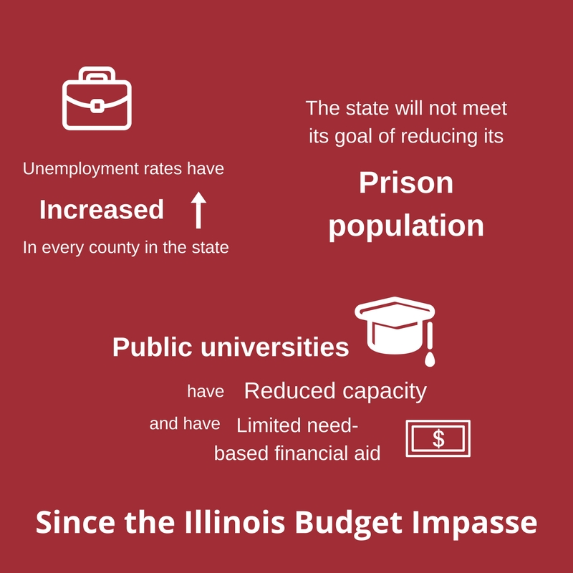
Research has shown that when the human service sector is suffering, there is a ripple effect that impacts employment, economic growth, and families. Declining support for human services can result in increased prison recidivism, more emergency room usage, greater strain on limited police and 911 call center resources, and rising drug abuse and unemployment rates. Furthermore, the decline of this sector also points to a loss of jobs, furthering a systemic impact on individual communities and the economy.

Above are some key findings published by Adler University’s Institute on Social Exclusion that highlight several alarming trends that are emerging from the Illinois’ budget impasse. These include: increased unemployment rates across the state of Illinois, a standstill in the state’s prison population, and restricted ability to provide financial support for prospective college students.
Effects on senior service providers can impact families and friends in caregiving roles. Service providers emphasize the importance of their services to provide assistance not only to seniors, but also those around them who need a break from caregiving. By providing homecare, meals, assisted transportation, etc., respite is granted to family members and friends, lessening potential stress and enhancing the quality of life for those individuals.

Research emphasizes that although those making decisions in the state government may have good intentions, the absence of a budget has had far-reaching, negative consequences for the residents of Illinois. However, a question still remains: what will be the lasting impacts of this 19-month budget impasse?

The Future
The impasse has served as the impetus of change for many aspects of Illinois, especially in regards to human services. It has led to Governor Rauner proposing a new senior care program he believes will cuts costs while providing innovative services to older adults. Nonprofit organizations are skeptical of the plan.

However, these agencies have more immediate concerns to address, namely finding ways to operate in the uncertain economic environment. The impasse continues to shape the financial landscape in Illinois and the decisions made by nonprofit providers.

Community Reinvestment Program

In 2005, there were 40,965 people enrolled in the Community Care Program (CCP), a statewide program established in 1979 to help senior citizens remain in their own homes by providing in home and community based services. Ten years later, that total more than doubled to 83,787 and by 2030, it is expected that Illinois’ aging population will double again.

The Community Reinvestment Program (CRP) was developed to serve seniors not covered by Medicaid and thus will not be eligible for CCP once a budget is passed. By continuing to provide in home and community based care, the state can avoid institutionalizing older adults, an effort that would cost hundreds of millions of dollars more.,

As part of the CRP, individuals who are not eligible for Medicaid would be qualified to receive a package of home and community based services. The Area Agency on Aging (AAA Network) will be responsible for coordinating preventative services.

Service providers, however, do not share Governor Rauner’s optimism about the program. They see nearly 44,000 older adults who are currently covered by the CCP who would be shifted to the CRP as a result of not being covered by Medicaid.

In addition, the CRP would cut $197.6 million from the Department on Aging’s budget. For the 44,000 seniors who would be placed in this program, this represents a cut of $4,520 to their annual services. For reference, under the CCP, seniors receive about $10,430 worth of care throughout the year.

While Governor Rauner attempts to cut spending and appease constituents, nonprofit organizations have had to make tough decisions of their own due to circumstances brought on by the budget impasse.

Agency Survival Methods

For nearly two years, agencies in Illinois have operated in uncertainty. Many are owed tens of thousands of dollars, if not hundreds of thousands or even more. While they anxiously await payments from the state, these organizations have pursued other avenues for finances.

Many have increased their fundraising efforts, relying more heavily on community members and other outside funders. The United Way of Greater St. Louis has been an advocate of this method, going so far as to help their member agencies create fundraising development plans.

In addition, some agencies have moved to fee-for-service systems. They are focusing on ways to diversify funding and generate more revenue. Senior Services Plus, for example, has expanded their catering service to serve a broader community and raise more funds. There are numerous other examples from other providers.

However, many organizations are forced to use less ideal means to sustain their service. These methods may include:

- Using cash reserves

- Not filling vacant positions

- Increasing waiting lists for services

- Laying off staff

- Reducing staff hours and/or benefits

- Referring clients to other service providers

- Using lines of credit

- Closing programs

- Changing services provided

- Implementing staff furlough days

- Skipping payroll

The survival strategies listed above are not sustainable methods of funding for organizations. Many service providers who spoke about the funding issues they were facing expressed concern about what these solutions being implemented mean for the future. Most of them felt as though they had no other options, and have prioritized staying open for as long as possible.

The stability of community organizations and their relationships with the state government in Illinois have been impacted over the past two years. Until there is more certainty with the state budget, community organizations have been approaching their work on a day-to-day basis.

Ways to Move Forward

For Funders:

- Consider special grant funding to support agencies negatively impacted by the budget impasse
- Fund research to better understand challenges facing nonprofits
- Share information and data amongst each other
- Give voice to communities that do not receive necessary attention
- Convene stakeholders and individuals being impacted

For Citizens:

- Donate to senior service agencies in your community
- Volunteer at your local senior service provider agency
- Call and write to your state representatives and urge them to pass a budget that adequately funds senior services
- Join advocacy efforts in Springfield with organizations like the Illinois AARP
- Regularly check-in with your family, friends, and neighbors who may be homebound seniors
- Engage in conversation with seniors in your community

For State Legislators:
- Pass a budget that adequately funds senior services
- Use evidence-based research to determine most cost-effective means of service (i.e. community and home based services)
- Involve clients, employees, and experts in senior services in developing policy
- Test policies with trial runs before full implementation
- Recognize the negative externalities of decisions and address them in future policymaking
- Address the needs of an aging population

Conclusion
The budget impasse in Illinois has significantly impacted human service providers in the state. For seniors and the agencies that serve them in southwestern Illinois, this impact has meant fewer home-delivered meals, dropped transportation programs, cuts to staff, and persistent uncertainty.

Nonprofit funders and individual donors are helping many agencies cover the gap. However, it has not been enough. These agencies and organizations, who serve a rapidly growing population of seniors who often do not receive the attention or resources they deserve, have joined other publically-funded programs suffering extreme cuts due to the state’s political divisions.

When the state does adopt the budget, service providers are worried that funding will not return to pre-impasse levels. The cuts proposed in the state’s Department on Aging’s Community Reinvestment Program have reinforced that unease among agency staff. Seniors we spoke to described feelings of stress, loneliness, and deep concern due to the cuts to many of the services they count on.

Funders can help agencies cope with what has been described as a potential “new normal” for senior service providers. The human value, sense of community, and physical and emotional support offered by these organizations must be recognized by those allocating state dollars moving forward.

This report was prepared by the CORO Fellows on behalf of the Daughters of Charity Foundation of St. Louis.

February 2017

Citations
- McKinney, Dave. "Illinois starts 2017 with no state budget." St. Louis Post-Dispatch. January 1, 2017. http://www.stltoday.com/business/local/illinois-starts-with-no-state-budget/article_f95f6eb1-9b6f-5674-8994-33efd5820030.html

- McGowan, Annie. “Failing to Keep Pace: An analysis of the Declining Value of Illinois Human Services Reimbursement Rates.” Illinois Partners for Human Services, February 2016, http://www.illinoispartners.org/wp-content/uploads/2015/04/ILPHS-Feb16-Report_Revised-2-25-2016.pdf

- The Urban Institute, NCCS Core Public Charities Fiscal Year Trend Data (Public Charities, 1989-2013).

- Internal Revenue Service, Exempt Organizations Business Master File. Public Charities, 12/2014, 12/2015, 8/2016.

- United States Census Bureau, QuickFacts Data. http://www.census.gov/quickfacts/table/PST120215/17119,17117,17083,17027,17013,17005 and http://www.census.gov/quickfacts/table/PST045216/17,17163,17133,00

- Administration for Community Living, agid.acl.gov. Data Source: Decennial Census 2010 Summary File 1 (SF1) Data.

- United States Census Bureau, American Community Survey 5-Year Estimates, Bond, Calhoun, Clinton, Jersey, Macoupin, Madison, Monroe, St. Clair Counties, https://factfinder.census.gov/faces/nav/jsf/pages/index.xhtml

- Institute for Research on Poverty. “How is poverty measured in the United States?” 6, Feb. 2017. http://www.irp.wisc.edu/faqs/faq2.htm

- Secter, Bob and Pearson, Rick. “Illinois income tax rate falls by 25 percent.” Chicago Tribune, Jan. 1, 2015. http://www.chicagotribune.com/news/local/breaking/ct-illinois-income-tax-rate-falls-met-20141230-story.html

- Bogan, Jesse and McDermott, Kevin. “Illinois budget impasse cuts food and transportation for vulnerable seniors.” St. Louis Post-Dispatch, Feb. 13, 2016. http://www.stltoday.com/news/local/govt-and-politics/illinois-budget-impasse-cuts-food-and-transportation-for-vulnerable-seniors/article_61156158-bfd9-5473-b695-8f4813b1ae59.html

- Burnett, Sara. “5 things you need to know about the Illinois budget crisis.” Associated Press, Chicago Daily Herald, June 1, 2016. http://www.dailyherald.com/article/20160531/news/160539864/

- Dunn, Jamey. “Illinois Issues: What Are Consent Decrees?” NPR Illinois, January 28, 2016. http://nprillinois.org/post/illinois-issues-what-are-consent-decrees#stream/0

- “Federal consent decrees: fact and fiction.” American Civil Liberties Union of Illinois, August 20, 2015. http://www.aclu-il.org/federal-consent-decrees-fact-and-fiction/

- Arnold, Tony. “Without a budget, courts step in to force state to pay bills.” WBEZ News, July 25, 2015. https://www.wbez.org/shows/wbez-news/without-a-budget-courts-step-in-to-force-state-to-pay-bills/36b2c43d-5cc2-46d7-8609-ba978e030bdf

- Garcia, Monique. “Interest payments on Illinois’ unpaid bills add to vast cost of budget impasse.” Chicago Tribune, Jan. 30, 2017. http://www.chicagotribune.com/news/local/politics/ct-illinois-budget-impasse-cost-met-20170129-story.html

- Patel, Devan. “Illinois impasse cripples state debt, investment.” Quad City Times, Jan. 31, 2017. http://qctimes.com/news/local/government-and-politics/illinois-budget-impasse-cripples-state-debt-investment/article_d659b1d4-2d90-5a3e-a0d0-25a12ad06c9a.html

- Garcia, Monique. “Interest payments on Illinois’ unpaid bills add to vast cost of budget impasse.”

- Adler University, Institute on Social Exclusion. The Downward Spiral: The Impact of Illinois’ Year Without a Budget. June 2016.

- Adler University, Institute on Social Exclusion.

- McGowan, Annie. “Failing to Keep Pace: An analysis of the Declining Value of Illinois Human Services Reimbursement Rates.”

- Nelson, Gayle. “18 Months of Budget Impasse in Illinois Stresses Nonprofits and Devastates Lives.” Nonprofit Quarterly, December 5, 2017, https://nonprofitquarterly.org/2016/12/05/18-months-budget-impasse-illinois-stresses-nonprofits-devastates-lives/

- “The Damage Done.” Illinois Partners for Human Services, 2016, http://www.illinoispartners.org/research/damage-done/idoa-providers/
- “Current research.” Illinois Partners for Human Services, 2016, http://www.illinoispartners.org/research/

- Fiske, Amy. “Depression in Older Adults,” National Institute of Health. April 10, 2010.

- Settle, Jill. “How Social Connections Keep Seniors Healthy,” The Greater Good at University of California, Berkeley. March 24, 2014.

- “Living Long and Well in the 21st Century: Strategic Directions for Research on Aging,” National Institute on Aging. November, 2007.

- Drathing, Ellen and Terpstra, Amy. “Need for Human Services in Illinois.” Social IMPACT Center at Heartland Alliance. 2011.

- Who we are,” HealthVisions Midwest. 2016. http://www.hvusa.org/index.php/about-us/who-we-are

- “Human Services as an Economic Engine: How Human Services in Illinois Drive Jobs and Economic Benefits,” Illinois Partners for Human Services. May, 2016. http://www.illinoispartners.org/wp-content/uploads/2016/05/Economic-Impact-Report-FINAL.pdf

- “Current research,” Illinois Partners for Human Services. 2016.

- Adler University, Institute on Social Exclusion.

- Illinois Department on Aging (DoA), FY2017 Budget. https://www.illinois.gov/aging/AboutUs/Documents/FY17ProposedBudget.pdf

- DoA FY2017 Budget.

- DoA Proposed Rules.

- Shen We Tan, “Governor Rauner Proposes 200 million in Cuts from Community Care Program,” Medill Reports, Chicago. March 3, 2016. http://news.medill.northwestern.edu/chicago/gov-rauner-proposes-nearly-200-million-in-budget-cuts-for-community-care-program/

- “Community Reinvestment Program Fact Sheet.” Illinois Department of Aging.

- DoA FY2017 Budget.

- Kaitlin DeCero, “Bruce Rauner Targets Seniors with 197.6 Million in Cuts,” SEIU. February 18, 2016.

- United Way of Greater St. Louis Illinois State Budget Impasse: 2016 Survey Results.

McKinney, Dave. "Illinois starts 2017 with no state budget." St. Louis Post-Dispatch. January 1, 2017.
McGowan, Annie. “Failing to Keep Pace: An analysis of the Declining Value of Illinois Human Services Reimbursement Rates.” Illinois Partners for Human Services, February 2016.
The Urban Institute, NCCS Core Public Charities Fiscal Year Trend Data (Public Charities, 1989-2013)
Internal Revenue Service, Exempt Organizations Business Master File. Public Charities, 12/2014, 12/2015, 8/2016.
United States Census Bureau, QuickFacts Data.
Administration for Community Living, agid.acl.gov. Data Source: Decennial Census 2010 Summary File 1 (SF1) Data.
United States Census Bureau, American Community Survey 5-Year Estimates.
Institute for Research on Poverty. “How is poverty measured in the United States?” 6, Feb. 2017
Secter, Bob and Pearson, Rick. “Illinois income tax rate falls by 25 percent.” Chicago Tribune, Jan. 1, 2015.
Bogan, Jesse and McDermott, Kevin. “Illinois budget impasse cuts food and transportation for vulnerable seniors.” St. Louis Post-Dispatch, Feb. 13, 2016.
Burnett, Sara. “5 things you need to know about the Illinois budget crisis.” Associated Press, Chicago Daily Herald, June 1, 2016.
Dunn, Jamey. “Illinois Issues: What Are Consent Decrees?” NPR Illinois, January 28, 2016.
“Federal consent decrees: fact and fiction.” American Civil Liberties Union of Illinois, August 20, 2015.
Arnold, Tony. “Without a budget, courts step in to force state to pay bills.” WBEZ News, July 25, 2015.
Garcia, Monique. “Interest payments on Illinois’ unpaid bills add to vast cost of budget impasse.” Chicago Tribune, Jan. 30, 2017.
Patel, Devan. “Illinois impasse cripples state debt, investment.” Quad City Times, Jan. 31, 2017.
Garcia, Monique. “Interest payments on Illinois’ unpaid bills add to vast cost of budget impasse.”
Adler University, Institute on Social Exclusion. The Downward Spiral: The Impact of Illinois’ Year Without a Budget. June 2016.
Adler University, Institute on Social Exclusion
McGowan, Annie. Illinois Partners for Human Services.
Nelson, Gayle. “18 Months of Budget Impasse in Illinois Stresses Nonprofits and Devastates Lives.” Nonprofit Quarterly, December 5, 2016.
“The Damage Done.” Illinois Partners for Human Services, 2016.
“Current research.” Illinois Partners for Human Services, 2016.
Fiske, Amy. “Depression in Older Adults,” National Institute of Health. April 10, 2010.
Suttle, Jill. “How Social Connections Keep Seniors Healthy,” The Greater Good at University of California, Berkeley. March 24, 2014.
“Living Long and Well in the 21st Century: Strategic Directions for Research on Aging,” National Institute on Aging. November, 2007.
Drathing, Ellen and Terpstra, Amy. “Need for Human Services in Illinois.” Social IMPACT Center at Heartland Alliance. 2011.
“Who we are,” HealthVisions Midwest. 2016.
“Human Services as an Economic Engine: How Human Services in Illinois Drive Jobs and Economic Benefits,” Illinois Partners for Human Services. May, 2016.
“Current research,” Illinois Partners for Human Services. 2016.
Adler University, Institute on Social Exclusion. The Downward Spiral: The Impact of Illinois’ Year Without a Budget. June 2016.
Illinois Department on Aging (DoA), FY2017 Budget.
DoA FY2017 Budget.
DoA Proposed Rules.
Shen We Tan, “Governor Rauner Proposes 200 million in Cuts from Community Care Program,” Medill Reports, Chicago. March 3, 2016.
“Community Reinvestment Program Fact Sheet.” Illinois Department of Aging.
“Community Reinvestment Program Fact Sheet.” Illinois Department of Aging.
Kaitlin DeCero, “Bruce Rauner Targets Seniors with 197.6 Million in Cuts,” SEIU. February 18, 2016.
United Way of Greater St. Louis Illinois State Budget Impasse: 2016 Survey Results.

